PERQUIMANS COUNTY
WALLACE E. NELSON
CHAIRMAN
CHARLES WOODARD
VICE CHAIRMAN
TIMOTHY J. CORPREW
JOSEPH W. HOFFLER
T. KYLE JONES
JAMES W. WARD
W. HACKNEY HIGH, JR.
COUNTY ATTORNEY
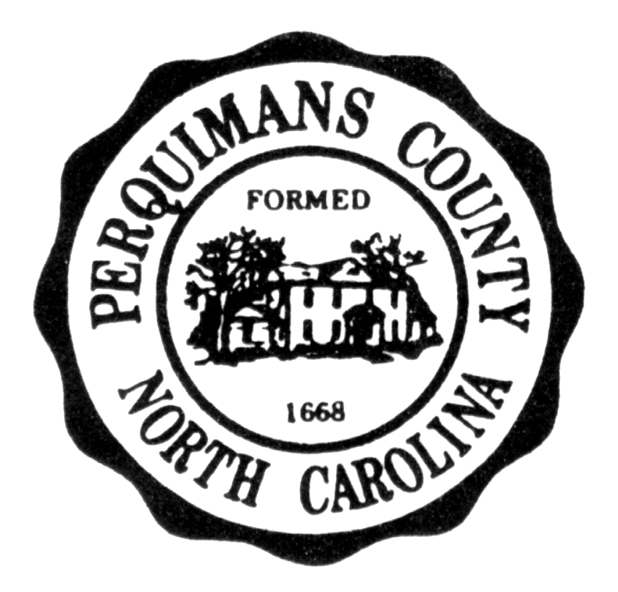
BOARD OF COMMISSIONERS

P.O. BOX 45
HERTFORD, NORTH CAROLINA 27944
TELEPHONE: 1-252-426-7550

MARY P. HUNNICUTT

CLERK TO BOARD

W. FRANK HEATH, III

COUNTY MANAGER

PUBLIC NOTICE

The Perquimans County Board of Commissioners will hold a Board Retreat on Monday, March 27, 2023, from 9:00 a.m. to 1:00 p.m. in the Conference Room of the Emergency Services Building located at 159 Creek Drive, Hertford, NC 27944. At this meeting, the Board will review long-term initiatives for the County. The Board will not take any action during this Retreat.

Frank Heath
Frank Heath, County Manager

